CLIENT-SIDE AUTHORIZATION BY PASSES AND UI MANIPULATION ASSESSMENT REPORT
Submitted By: Abhishek N Shetty
Submission Date: 10 June 2026

INTRODUCTION
Modern web applications increasingly rely on client-side frameworks such as Angular to deliver dynamic and responsive user experiences. Angular applications execute a significant portion of their logic within the user's browser, including navigation, user interface rendering, and certain access control decisions.
Client-side authorization mechanisms are often implemented to improve usability by hiding or restricting features that should not be accessible to specific users. Examples include hiding administrative menus, disabling buttons, restricting forms, and controlling route access through Angular Route Guards.
While these controls enhance the user experience, they should not be considered security mechanisms. Since client-side code is executed on the user's device, it can be inspected, modified, or manipulated using browser developer tools. An attacker may attempt to bypass these controls by altering client-side values, modifying application state, or directly interacting with backend APIs.
To prevent unauthorized access, all critical authorization decisions must be validated by the backend server. Even if a user gains access to hidden functionality in the browser, the server should independently verify permissions before allowing any sensitive operation.
This assessment focuses on understanding Angular client-side authorization controls and evaluating whether backend authorization mechanisms are properly implemented to protect sensitive resources and application functionality.
ANGULAR ROUTING AND ROUTE GUARDS
Angular Routing
Angular Routing is a mechanism that enables navigation between different components and pages within a single-page application. Instead of reloading entire web pages, Angular dynamically loads content based on the requested route.
Common examples of routes include:
• /login
• /dashboard
• /profile
• /reports
• /admin

Routing improves user experience by providing faster page transitions and reducing server requests.

Hidden Routes
Some routes may not be visible in the application's navigation menu but still exist within the routing configuration. These routes are commonly referred to as hidden routes. Hidden routes should never be relied upon as a security mechanism because users may discover them through browser inspection or source code analysis.

Lazy Loaded Modules
Angular supports lazy loading, which allows feature modules to be loaded only when required. This improves application performance and reduces initial page load times.
Route Guards
Route Guards are Angular security features used to control navigation between routes. They help determine whether a user should be allowed to access a specific route.
Common Angular Route Guards include:
1. CanActivate
Determines whether a route can be accessed.
2. CanActivateChild
Controls access to child routes.
3. CanLoad
Prevents modules from loading until access requirements are satisfied.
4. Resolve
Retrieves required information before route activation.

Authentication and Authorization
Authentication verifies the identity of a user. Authorization determines what resources the authenticated user is permitted to access.
Examples of authentication methods include usernames, passwords, session tokens, and JWT tokens.
Authorization is commonly based on user roles such as:
• Administrator
• Manager
• Employee
• Standard User
A secure application must enforce authorization checks on both the client side and the server side. Backend validation remains the most important security control because client-side restrictions can be bypassed or manipulated.

Hidden Parameter Tampering
Introduction
Hidden Parameter Tampering is a security testing technique where an attacker modifies values that developers intended users not to change. These values are often stored in hidden fields, disabled form fields, feature flags, or client-side role checks.
The main issue is that anything sent to the browser can be modified by the user. Therefore, sensitive decisions should never rely solely on client-side controls.

1. Disabled Form Fields
What are Disabled Form Fields?
Developers sometimes disable input fields so users cannot edit them through the normal interface.
Example
<input type="text" name="price" value="1000" disabled>

2. Hidden Input Fields
What are Hidden Fields?
Hidden fields are form inputs that are not visible to users.
Example
<input type="hidden" name="userRole" value="user">

3. Feature Flags
What are Feature Flags?
Feature flags are settings used to enable or disable application features.
Example
JavaScript:
if(featureFlag.adminPanel){
showAdminPanel();
}

4. Client-Side Role Checks
What are Client-Side Role Checks?
Some applications decide what users can see based on JavaScript role values.
Example
if(user.role === "admin"){
showAdminDashboard();
}

Cosmetic Security vs Backend Enforcement
Many web applications attempt to restrict functionality by hiding buttons or disabling features in the user interface.
This is called Cosmetic Security because it only affects appearance, not actual security.
True security must be enforced by the backend server.

1. Why Hiding Buttons is Not Security
Example
Normal user:
<button style="display:none">
Delete User
</button>
The button cannot be clicked normally.
Problem
An attacker can:
- Remove the disabled attribute.
- Trigger the action manually.
- Send direct API requests.
Important Concept
Authorization means:
Verifying whether a user is allowed to perform an action.
Disabling a button only changes the interface and does not enforce authorization.

2. Why Disabling UI Elements is Not Authorization
Example
<button disabled>
Delete Account
</button>
The button cannot be clicked normally.
Problem
An attacker can:
- Remove the disabled attribute.
- Trigger the action manually.
- Send direct API requests.
Important Concept
Authorization means:
Verifying whether a user is allowed to perform an action.
Disabling a button only changes the interface and does not enforce authorization.
3. Importance of Server-Side Validation
What is Server-Side Validation?
The backend independently verifies every request.
Checks Performed
- User authentication
- User authorization
- Input validation
- Business logic validation
- Resource ownership validation
Example
User attempts:
DELETE /api/users/100

4. Backend Access Control Mechanisms
Role-Based Access Control (RBAC)
Permissions are assigned based on roles.
Example:
Role | Permission
User | View Profile
Manager | Manage Team
Admin | Manage Users
Backend check’s role before processing requests.
Attribute-Based Access Control (ABAC)
Access depends on attributes.
Example:
User Department = Finance
Resource Department = Finance
Access granted only if attributes match.

Route Discovery – Source Code Inspection and Route Search

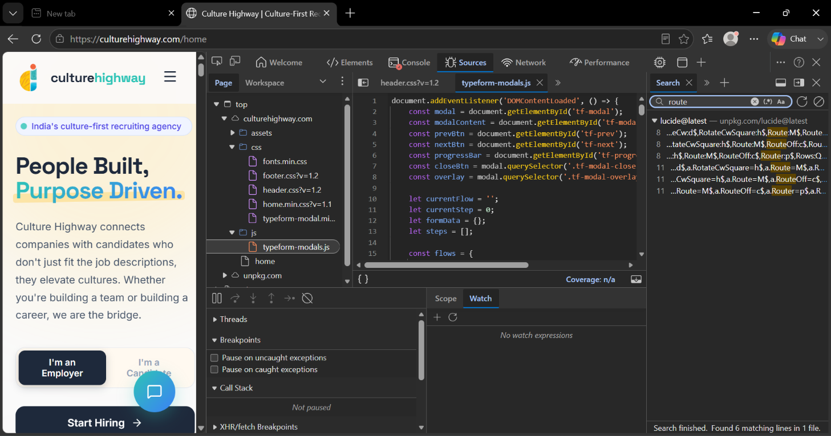
Tools and Components Observed
1. Sources Tab
The Sources tab is the primary tool used during this assessment.
Purpose:
- View application source files.
- Inspect JavaScript and CSS resources.
- Analyze client-side functionality.
- Search for route definitions and navigation logic.
- Identify hidden functionality exposed through source code.
Why it was used:
The Sources tab was used to inspect the files loaded by the application and search for route-related information that could reveal application structure and navigation paths.

2. Search Panel
The Search panel is visible on the right side of the Developer Tools window.
Purpose:
- Search across all loaded source files.
- Locate keywords related to routing and navigation.
- Identify hidden references within JavaScript code.
Keyword Used:
route
Why it was used:
Searching for route-related keywords helps identify routing mechanisms, navigation paths, feature modules, hidden pages, and route configurations that may not be visible through the user interface.

3. JavaScript File Inspection
The file being analyzed is:
typeform-modals.js
Purpose:
- Review application logic.
- Understand client-side functionality.
- Identify user workflows and navigation behavior.
- Locate references to routes, redirects, and feature modules.
Why it was used:
JavaScript files often contain information about application functionality, navigation flows, user actions, and hidden features. Reviewing these files helps analysts understand how the application operates.

4. Application Resource Explorer
The resource tree displayed on the left side contains:
culturehighway.com
├── assets
├── css
├── js
└── home
Purpose:
- Display all resources loaded by the application.
- Provide access to source files.
- Help identify application components and functionality.
Why it was used:
Reviewing available resources allows analysts to understand the application's structure and determine where route definitions or navigation logic may be stored.

5. CSS Files
The following CSS files are visible:
fonts.min.css
footer.css
header.css
home.min.css
typeform-modal.min.css
Purpose:
- Define the visual appearance of the application.
- Control layout and user interface elements.
Why they were reviewed:
Although CSS files do not usually contain routes, they help analysts understand page structure and identify hidden interface elements that may indicate additional functionality.

6. JavaScript Directory
The JavaScript folder contains:
js/
└── typeform-modals.js
Purpose:
- Store application logic.
- Handle user interactions.
- Manage navigation and dynamic functionality.
Why it was inspected:
JavaScript files frequently contain references to application routes, redirects, API calls, and feature modules that are useful during route discovery.

7. Website Navigation Components
The application interface displays:
- Home Page
- Employer Section
- Candidate Section
- Start Hiring Feature
Purpose:
These components represent visible functionality available to users.
Why they are important:
Visible navigation elements help identify accessible routes and provide insight into the application's functional structure.

Route Discovery Activities Performed
During this assessment, the following actions were completed:
- Opened Browser Developer Tools (F12).
- Accessed the Sources tab.
- Inspected application resources.
- Reviewed JavaScript and CSS files.
- Performed a route-related keyword search.
- Examined search results for navigation information.
- Identified visible application functionality.
- Documented observations and findings.

Route Guard Analysis.

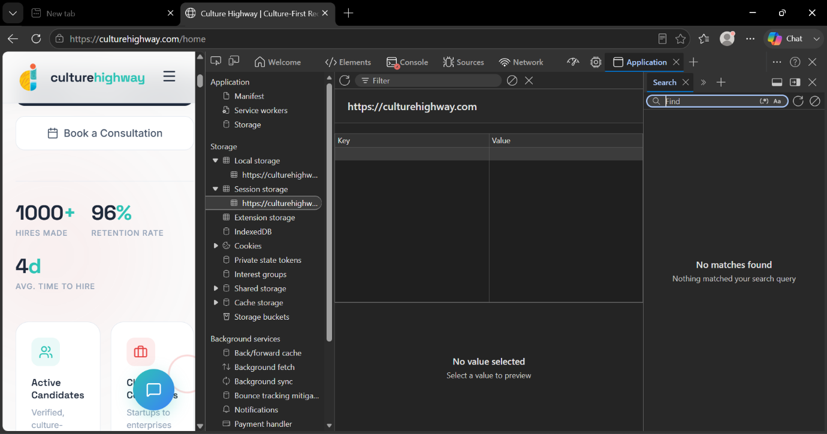
Route Guard Analysis – Browser Storage Inspection
The above screenshot shows the Application tab of Browser Developer Tools being used during the Route Guard Analysis assessment. This tab provides access to browser storage mechanisms that may contain authentication and authorization-related information used by the application.
The objective of this activity was to determine whether sensitive information such as authentication tokens, user roles, feature flags, permission attributes, or session identifiers was being stored on the client side. Browser storage analysis is important because applications that store authorization data locally may be vulnerable to manipulation attacks.
Tools and Components Reviewed
Application Tab
- Used to inspect client-side storage and security-related information.
- Helps identify authentication and authorization data stored in the browser.
Local Storage
- Reviewed for JWT tokens, authentication tokens, user roles, permissions, and feature flags.
- No authorization-related values were identified during the assessment.
Session Storage
- Reviewed for session tokens, access indicators, and temporary authentication information.
- No stored values, authentication tokens, or authorization attributes were observed.
Cookies and IndexedDB
- Examined as potential locations for authentication and session-related information.
- These storage mechanisms are commonly used by web applications to maintain user sessions and application data.
Activities Performed
- Opened Browser Developer Tools (F12).
- Accessed the Application tab.
- Reviewed Local Storage and Session Storage.
- Inspected available browser storage resources.
- Checked for authentication tokens, user roles, permissions, and feature flags.
- Documented observations and findings.

Findings
The browser storage analysis did not reveal any authentication tokens, user roles, permission attributes, feature flags, or other authorization-related information. No client-side authorization artifacts were identified within the reviewed storage mechanisms.

Security Considerations
Applications should not rely solely on client-side storage for authorization decisions. If sensitive information such as roles or permissions is stored in the browser, attackers may attempt to modify these values to gain unauthorized access. Therefore, all authorization decisions should be validated on the server side.

Exercise 3 – Client-Side State Analysis
EXERCISE 3 – CLIENT-SIDE STATE ANALYSIS
Objective
The objective of this exercise was to analyze the client-side storage mechanisms used by the application and identify information related to authentication, authorization, user roles, permissions, and feature management. The assessment aimed to determine how application state is maintained on the client side and whether any security-sensitive information is exposed within browser storage.

Methodology
The assessment was performed using Browser Developer Tools. The Application tab was used to review browser storage locations and identify information related to authentication, authorization, session management, and application state.
The following storage mechanisms were examined:
- Local Storage
- Session Storage
- Browser Cookies
The assessment focused on identifying:
- User Roles
- Authentication Tokens
- Session Identifiers
- Feature Flags
- Access Indicators
- Permission Attributes

Local Storage Analysis
Local Storage was reviewed to determine whether the application stores persistent authorization-related information within the browser.
The following items were examined:
- User role values
- Authentication tokens
- Feature flags
- Permission attributes
- Access control indicators
During the assessment, no Local Storage entries containing authorization-related information were identified. No user roles, authentication tokens, feature flags, or permission attributes were observed.

Session Storage Analysis
Session Storage was reviewed to identify temporary authentication and authorization data maintained during the active browser session.
The following information was examined:
- Session identifiers
- User context data
- Authentication information
- Permission attributes
No stored values were identified within the reviewed Session Storage resources. No authentication tokens, role identifiers, or access indicators were observed.

Browser Cookie Analysis
Browser cookies were reviewed as part of the assessment because web applications commonly use cookies for session management and authentication.
The review focused on identifying:
- Session identifiers
- Authentication cookies
- Security flags
- Cookie expiration attributes
Additional verification may be required to fully assess cookie-based authentication mechanisms used by the application.

Storage Findings
Storage Type | Observation | Security Relevance
Local Storage | No authorization-related values identified | Low
Session Storage | No authentication or role information identified | Low
Browser Cookies | Reviewed for session management information | Medium

Observations
The client-side storage analysis did not reveal any authentication tokens, user roles, permission attributes, feature flags, or access control indicators within the reviewed browser storage mechanisms. Based on the available information, the application does not appear to rely on visible Local Storage or Session Storage resources for maintaining authorization state.
Security Considerations
The following security risks may arise when applications rely on client-side information for authorization decisions:
- Role Manipulation
  - User role values stored in browser storage may be modified.
- Feature Flag Manipulation
  - Hidden functionality may become accessible if feature values are altered.
- Unauthorized UI Changes
  - Application interfaces may change based on modified client-side values.
- Insecure Trust Relationships
  - Applications that trust client-side values may become vulnerable to privilege escalation.
No evidence of these issues was identified during the assessment.
Questions and Answers
1. Does the UI Change?
Observation:
No user interface changes were observed because no authorization-related values were identified within the reviewed browser storage locations.
2. Does Access Actually Increase?
Observation:
Client-side modifications do not automatically increase privileges. Access should only be granted after successful backend authorization checks.
3. Does the Backend Reject Unauthorized Requests?
Observation:
A secure application should validate permissions on the server side and reject unauthorized requests regardless of client-side modifications.
UI Restriction Analysis – HTML Structure and Frontend Component Inspection
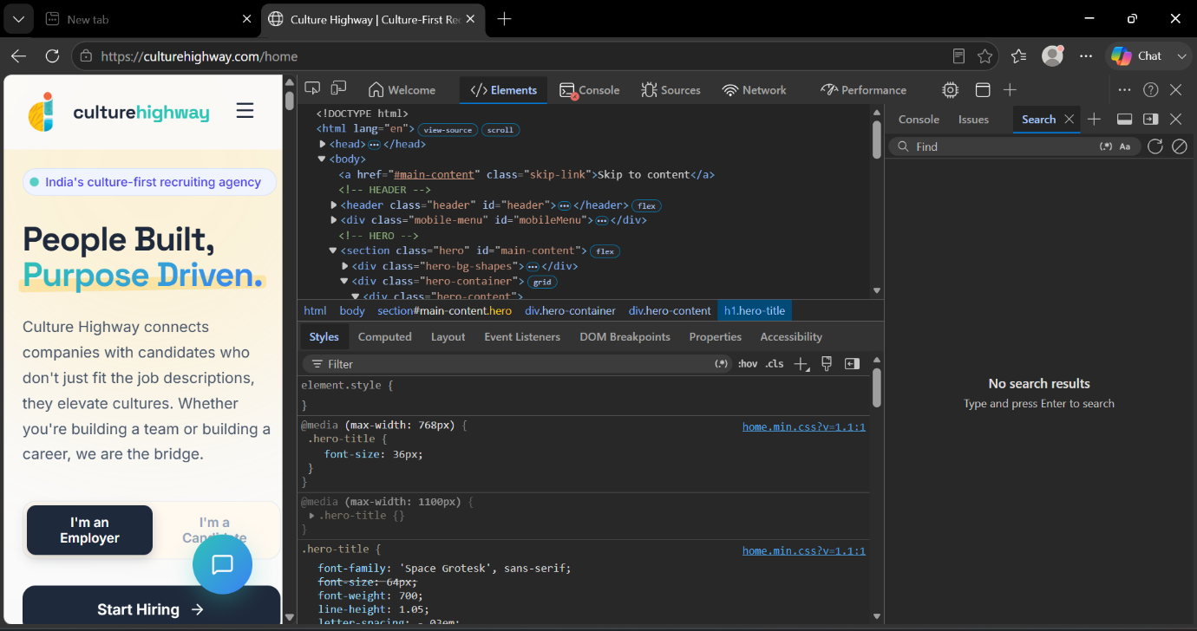

Components Identified During Inspection
1. HTML Document Structure
The application begins with the standard HTML document structure:
<!DOCTYPE html>
<html>
<head>
<body>
Purpose:
These elements form the foundation of the webpage. The HTML document defines the overall structure of the application, while the head section contains metadata and resource references. The body section contains all visible content displayed to users.

2. Header Component
The following element was identified:
<header class="header" id="header">
Purpose:
The header component is responsible for displaying the website logo, navigation controls, menu options, and other top-level interface elements.
Why it is important:
Headers often contain navigation menus and access points to application functionality. During UI Restriction Analysis, headers are reviewed to determine whether menu items are hidden based on user roles or permissions.

3. Mobile Menu Component
The following element was observed:
<div class="mobile-menu" id="mobileMenu">
Purpose:
This component provides navigation functionality for mobile and responsive devices.
Why it is important:
Applications frequently show or hide menu items within mobile navigation components based on user permissions. Reviewing this element helps identify hidden functionality or restricted navigation options.

4. Main Content Section
The following section was identified:
<section class="hero" id="main-content">
Purpose:
This section contains the primary content displayed to users when they access the application.
Why it is important:
Security analysts review content sections to identify protected functionality, hidden content, role-based components, or restricted interface elements.

5. Hero Container and Content Components
The following elements were observed:
<div class="hero-container">
<div class="hero-content">
<h1 class="hero-title">
Purpose:
These elements are responsible for presenting the application's primary content and user-facing information.
Why they are important:
Frontend applications often dynamically display or hide content based on user permissions. Inspecting these components helps determine whether access restrictions are implemented only through the user interface.

6. CSS Styling Rules
The Styles panel displays CSS rules such as:
.hero-title {
font-size: 64px;
font-weight: 700;
}
Purpose:
CSS controls the appearance, visibility, layout, and behavior of interface elements.
Why it is important:
Many applications hide interface elements using CSS properties such as:
display: none;
visibility: hidden;
opacity: 0;
Reviewing CSS rules helps identify hidden buttons, menus, forms, or administrative functionality that may not be visible to users.

UI Restriction Analysis Activities Performed
During this assessment, the following actions were completed:
- Opened Browser Developer Tools using F12.
- Accessed the Elements tab.
- Reviewed the HTML document structure.
- Inspected navigation and menu components.
- Examined content sections and interface elements.
- Reviewed CSS rules affecting visibility and display.
- Checked for hidden menus, disabled buttons, and restricted controls.
- Documented observations and findings.

Findings
The inspection identified standard website components including the header section, mobile navigation menu, content sections, and styling rules. No hidden administrative menus, disabled administrative buttons, restricted forms, or security-sensitive read-only controls were identified during the review.
No evidence was found indicating that access restrictions were being enforced solely through visible client-side interface controls.

Authorization Validation – Network Traffic Inspection
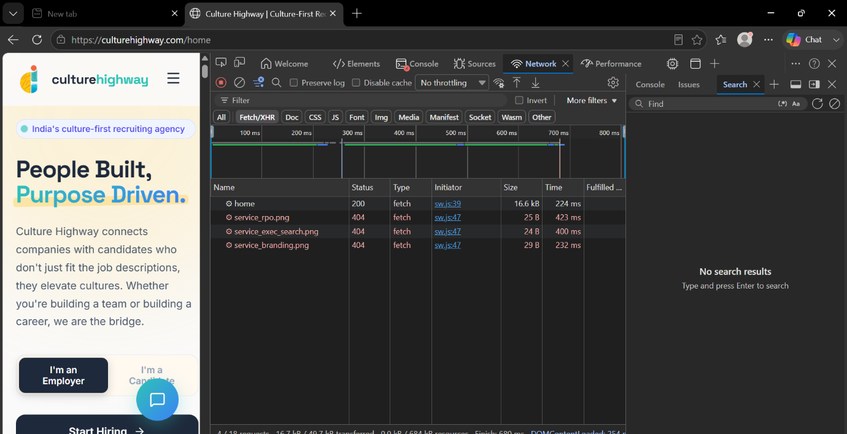

The objective of this activity was to analyze network traffic and determine whether backend systems enforce authentication and authorization controls when processing application requests.
During the assessment, multiple requests generated by the application were observed. The request named home returned an HTTP 200 OK status code, indicating that the request was successfully processed by the server. Additional resource requests returned 404 Not Found responses, indicating that the requested resources were unavailable.
Activities Performed
- Opened Browser Developer Tools (F12).
- Accessed the Network tab.
- Enabled the Fetch/XHR filter.
- Monitored requests generated during application usage.
- Reviewed request names and response status codes.
- Documented observations and findings.

Findings
Request | Status Code | Observation
home | 200 OK | Request successfully processed
service_rpo.png | 404 Not Found | Resource unavailable
service_exec_search.png | 404 Not Found | Resource unavailable
service_branding.png | 404 Not Found | Resource unavailable
Security Observation
The Network tab provides visibility into communication between the client and the backend. Monitoring network traffic helps identify protected resources, authentication mechanisms, authorization controls, and server responses. The presence of successful and unsuccessful requests demonstrates how the server handles resource access and request processing.

RISK ASSESSMENT SUMMARY
The assessment identified various client-side security controls implemented within the Angular application. The review focused on routing mechanisms, route guards, client-side storage, user interface restrictions, and backend authorization enforcement.
The majority of identified controls were implemented to improve user experience and application usability. However, client-side mechanisms alone should not be considered sufficient security controls because they can be inspected and manipulated by users.
The risk assessment evaluated the potential impact of authorization weaknesses and the effectiveness of backend validation mechanisms.
Risk Rating Criteria
Critical:
Complete authorization bypass resulting in unrestricted access to sensitive resources.
High:
Privilege escalation leading to unauthorized administrative actions.
Medium:
Partial authorization weaknesses that could expose restricted functionality.
Low:
Minor observations with limited security impact.
Informational:
No direct security impact but useful for security awareness and improvement.
Risk Assessment Table
Severity | Count
Critical | 0
High | 0
Medium | 1
Low | 3
Informational | 5
Overall Risk Rating
Based on the observations recorded during the assessment, the overall security posture of the application indicates that backend authorization controls play a critical role in protecting sensitive functionality. Applications should continue enforcing authorization decisions on the server side to reduce the risk of unauthorized access.

RECOMMENDATIONS
The following recommendations are provided to strengthen authorization security and reduce the risk of unauthorized access.
- Enforce Server-Side Authorization
All sensitive actions should be validated by the backend regardless of any client-side restrictions. Authorization decisions should never rely solely on information stored within the browser.
Priority: High
- Implement Role-Based Access Control
Role validation should be enforced at the server level for all protected resources and administrative functionality.
Priority: High
- Secure Client-Side Storage
Authentication tokens, session identifiers, and authorization-related information should be stored securely and validated by the backend.
Priority: Medium
- Validate Every API Request
Each API endpoint should independently verify user permissions before processing requests.
Priority: High
- Restrict Access to Sensitive Functionality
Administrative features and internal application components should be protected through backend authorization controls.
Priority: High
- Implement Security Logging
Authorization failures and suspicious access attempts should be logged and monitored for security analysis.
Priority: Medium
- Conduct Regular Security Assessments
Periodic security reviews should be performed to identify weaknesses in authorization mechanisms and access control implementations.
Priority: Medium
Conclusion of Recommendations
The implementation of strong backend authorization controls significantly reduces the risk of privilege escalation, unauthorized access, and business logic abuse. Security controls should always be validated on the server side to ensure effective protection of application resources.

EXECUTIVE SUMMARY
This assessment was conducted to evaluate client-side authorization mechanisms and user interface restrictions within an Angular-based web application. The review focused on route discovery, route guard analysis, client-side storage inspection, UI restriction analysis, and backend authorization validation.
The assessment demonstrated that client-side controls such as hidden menus, disabled buttons, restricted forms, and route guards primarily serve usability purposes and should not be considered security controls. Since client-side code executes within the user's browser, it may be inspected or manipulated using standard developer tools.
The review emphasized the importance of backend authorization enforcement. Secure applications should validate authentication, roles, permissions, and access rights on every sensitive request regardless of client-side behavior.
CONCLUSION
The Client-Side Authorization Bypass and UI Manipulation Assessment provided valuable insight into how Angular applications manage access control and authorization decisions.
The assessment demonstrated that frontend security controls improve the user experience but cannot provide complete protection against unauthorized access. Hidden routes, disabled controls, and client-side role checks may be discovered or manipulated by users if backend validation is absent.
A secure application must enforce authorization checks on every protected resource and API endpoint. Proper server-side validation remains the most effective defense against privilege escalation and unauthorized functionality exposure.
Overall, the assessment reinforced the principle that authorization should always be enforced on the backend while client-side controls should be used only as usability enhancements. The findings and recommendations documented within this report provide guidance for improving the application's security posture and strengthening access control mechanisms.

